Supplementary material

# Supplementary material 1. Parents’ informed letters of popularization of emergency treatment and prevention measures of children’s dental trauma

Dear parents,

We are a research team from the Department of Stomatology of Tianhe district XianCun street community health service center. Our main members are senior oral general practitioners. In order to further popularize the prevention and treatment knowledge of children’s dental trauma and reduce the occurrence of children’s oral injury, we will go to primary schools in Guangzhou City to carry out popular science lectures on children’s dental trauma knowledge and distribute publicity materials. According to the requirement of the project, we will use questionnaire to investigate the cognition of tooth trauma of school children and their parents. The questionnaire survey will be conducted in two sessions, one before the lecture and the other after the lecture.

In addition to promoting and popularizing the skills of emergency treatment of children’s dental trauma, the lecture enables students, teachers and parents to grasp the “Self-help” measures on the spot and grasp the “Golden” time for treatment, in addition to improving the late effects of traumatic teeth, we will also carry out dental care and tooth decay prevention education, in order to maintain your child and more other children’s oral health, we invite you and your children to participate. Thank you!

We Promise: All data will be used only for scientific research, data will be reported anonymously and will not be made public without parental consent.

Thanks again for your support!

I wish you a happy and healthy family!

Children’s name:

Class and grade:

Parent’s name:

Department of Stomatology of Tianhe district XianCun street community health service center

26 August 2016

# Supplementary material 2. Questionnaire for children’s dental trauma on the cognitive level (before the lecture)

School: Class and Grade: Name: Gender: Age:

Dear children,

The purpose of this questionnaire is to find out what you know about dental trauma. The questionnaire will not affect your academic performance, do not have scruples. Please fill in the form according to your true opinion. There is only one answer for each question. Please tick in the parentheses after the correct answer. Please answer the questions one by one. Thank you for your cooperation!

1. When children begin to lose their milk teeth?

A. 6 months after birth ( ) B. At six ( )

C. At twelve ( ) D. At eighteen ( )

2. How do you obtain first-aid knowledge of dental trauma?

A. From TV, newspapers, *etc.* ( ) B. From Parent ( ) C. From doctor ( )

D. Form teacher ( ) E. Never got it ( )

3. Do you know the location and opening time of oral emergency near school or home?

A. Know ( ) B. Hear nothing of ( )

4. Is it a primary tooth or a permanent tooth when a 9-year-old child fell and broke his upper front tooth?

A. Primary tooth ( ) B. Permanent tooth ( )

5. Should you put the primary teeth back into the original alveolar socket after trauma?

A. Yes ( ) B. No ( )

6. Do you think it will affect the permanent teeth after primary dental trauma?

A. Yes ( ) B. No ( )

7. Do you wear a protective mouthpiece during strenuous exercise?

A. Yes ( ) B. No ( )

8. How do you deal with the teeth when it hit and broken?

A. No treatment ( ) B. Go to the hospital without the broken teeth ( )

C. Take the broken tooth to the hospital immediately ( )

D. Go to the hospital wait when toothache ( )

9. How do you deal with the knocked-out permanent teeth?

A. Don’t know what to do ( ) B. Go to the hospital without the knocked-out permanent teeth ( )

C. Take the knocked-out permanent teeth and go to the hospital immediately ( )

D. Put the lost teeth in your mouth and go to the hospital immediately ( )

10. Which is the most suitable preservation methods of knocked-out permanent teeth?

A. Wrapping in clean paper or cloth ( ) B. Soaking in cold milk ( )

C. Soaking in clean water ( ) D. Soaking in normal saline ( )

11. When is the golden time for placement of completely lost permanent teeth?

A. Within 30 minutes ( ) B. within 3 hours ( )

C. Within 24 hours ( ) D. Within 48 hours ( )

12. Do your front teeth has a history of dental trauma?

A. Yes ( ) B. No ( )

13. Who is the first people to help when you have dental trauma?

A. School doctor ( ) B. Parent ( ) C. Doctor ( ) D. Other people ( )

Thank you for your cooperation!

# Supplementary material 3. Questionnaire for children’s dental trauma on the cognitive level (after the lecture)

School: Class and Grade: Name: Gender: Age:

Dear children,

The purpose of this questionnaire is to find out what you know about dental trauma. The questionnaire will not affect your academic performance, do not have scruples. Please fill in the form according to your true opinion. There is only one answer for each question. Please tick in the parentheses after the correct answer. Please answer the questions one by one. Thank you for your cooperation!

1. Do you think it will affect the permanent teeth after primary dental trauma?

A. Yes ( ) B. No ( )

2. Who is the first people to help when you have dental trauma?

A. School doctor ( ) B. Parent ( ) C. Doctor ( ) D. Other people ( )

3. Do you know the location and opening time of oral emergency near school or home?

A. Know ( ) B. Hear nothing of ( )

4. Is it a primary tooth or a permanent tooth when a 9-year-old child fell and broke his upper front tooth?

A. Primary tooth ( ) B. Permanent tooth ( )

5. Should you put the primary teeth back into the original alveolar socket after trauma?

A. Yes ( ) B. No ( )

6. When children begin to lose their milk teeth?

A. 6 months after birth ( ) B. At six ( )

C. At twelve ( ) D. At eighteen ( )

7. Do you wear a protective mouthpiece during strenuous exercise?

A. Yes ( ) B. No ( )

8. How do you deal with the teeth when it hit and broken?

A. No treatment ( ) B. Go to the hospital without the broken teeth ( )

C. Take the broken tooth to the hospital immediately ( )

D. Go to the hospital Wait when toothache ( )

9. How do you deal with the knocked-out permanent teeth?

A. Don’t know what to do ( ) B. Go to the hospital without the knocked-out permanent teeth ( )

C. Take the knocked-out permanent teeth and go to the hospital immediately ( )

D. Put the lost teeth in your mouth and go to the hospital immediately ( )

10. Which is the most suitable preservation methods of knocked-out permanent teeth?

A. Wrapping in clean paper or cloth ( ) B. Soaking in cold milk ( )

C. Soaking in clean water ( ) D. Soaking in normal saline ( )

11. When is the golden time for placement of completely lost permanent teeth?

A. Within 30 minutes ( ) B. Within 3 hours ( )

C. Within 24 hours ( ) D. Within 48 hours ( )

12. How do you obtain first-aid knowledge of dental trauma?

A. From TV, newspapers, *etc.* ( ) B. From Parent ( )

C. From doctor ( ) D . Form teacher ( ) E. Never got it ( )

13. Please make a comment on this lecture.

A. Content is vivid and interesting ( ) B. Learn new knowledge ( )

C. Hope to hear more of these lectures ( ) D. Content is not attractive ( )

Thank you for your cooperation!

# Supplementary material 4. Questionnaire for parent’s dental trauma on the cognitive level (before the lecture)

Name: Gender: Age: Relationship with children: Cultural background:

Dear parents,

This questionnaire is only used for the research, the issues involved in strict confidentiality, I hope you take out valuable time to participate in our survey, to provide real and effective information. All the questions below are single-choice questions. Please fill in the answers in parentheses. Thank you for your cooperation!

1. Do your children have a history of dental trauma? ( )

A. Yes B. No

2. Do you know the location and opening time of oral emergency near school or home? ( )

A. Know ( ) B. Hear nothing of ( )

3. Should you put the primary teeth back into the original alveolar socket after dental trauma? ( )

A. Yes ( ) B. No ( )

4. Do you think children should wear a protective mouthpiece during strenuous exercise? ( )

A. Yes ( ) B. No ( )

5. Have you received the first aid training for children with dental trauma? ( )

A. Yes ( ) B. No ( )

6. How do you obtain first-aid knowledge of dental trauma? ( )

A. From TV, newspapers, *etc.* ( ) B. From relatives and friends ( )

C. From medical staff ( ) D . Form community health education ( ) E. Never got it ( )

7. Do you think dental trauma will affect your appearance? ( )

A. Yes ( ) B. No ( )

8. Do you think dental trauma will affect mastication? ( )

A. Yes ( ) B. No ( )

9. Do you think dental trauma can affect intelligence or memory? ( )

A. Yes ( ) B. No ( )

10. Do you think it will affect the permanent teeth after primary teeth trauma? ( )

A. Yes ( ) B. No ( )

11. What do you think is the most common cause of dental trauma? ( )

A. Fell and hurt B. Traffic accidents C. Bite hard D. Bruises

12. Where your teeth are vulnerable to trauma? ( )

A. School B. Home C. Public places of entertainment D. Road

13. When your teeth are vulnerable to trauma? ( )

A. During at school B. Weekends C. Summer vacation D. Winter vacation

14. Where dental trauma is more likely to occur at school? ( )

A. In the classroom B. Corridor C. Playground D. Toilet

15. Where dental trauma is more likely to occur in your family? ( )

A. Kitchen B. Living Room C. Toilet D. Balcony

16. Which do you think is more valuable in prevention or treatment of permanent tooth trauma? ( )

A. Prevention B. Treatment

17. When will you take your children to the dentist? ( )

A. Check regularly B. Discovery dental disease C. Affect eating D. Toothache

18. What kind of regular dental check do you favor? ( )

A. School organized to check B. Parents take to check C. Dentist went to check on the school

19. Do you agree to have a dental education in school every year? ( )

A. Agree B. Disagree

20. What is the reason for you not bring your children to the hospital after dental trauma? ( )

A. Afraid to go to the dentist B. High cost C. Feel not serious D. No Time

21. The most common manifestation of permanent anterior dental trauma is ( ).

A. Broken crown B. Crown and root broken C. Subluxation of teeth D. Total dislocation

22. The most common site of permanent anterior dental trauma is ( ).

A. Maxillary central incisor B. Maxillary lateral incisors C. Mandibular central incisor D. Fangs

23. Do you need to go to the hospital if your teeth not shift or come out after dental trauma? ( )

A. Need B. No need

24. When children begin to lose their primary teeth? ( )

A. 6 months after birth ( ) B. At six ( )

C. At twelve ( ) D. At eighteen ( )

25. Scenario answer:

Example 1: An 8-year-old child in PE class, accidentally his face was hit by a ball, part of his lower front tooth was broken, his lower lip was swelling and part of gum were bleeding.

1. Is the lower front tooth primary or permanent? ( )

A. Primary teeth B. Permanent teeth

2. How do you deal with this dental trauma? ( )

A. No pain, no treatment B. Children can have their teeth replaced without treatment

C. Just stop the bleeding D. Go to the hospital at once

E. Go to the hospital and take with the broken tooth

Example 2: An 11-year-old child was playing at home when he fell from a height place, one of his upper front tooth causing a complete dislocation and part of the gums and lips were bleeding.

1. How do you deal with this dental trauma? ( )

A. Just stop the bleeding B. Go to the hospital without take the broken tooth

C. Go to the hospital with the broken tooth

D. Put the tooth back in the socket before go to the hospital E. Don’t know what to do

2. which of the following ways is right, if you want to clean your teeth which is drop in the ground? ( )

A. Take the teeth and rinse them under the faucet until they are clean

B. Rub the teeth and rinse with running water until they are clean

C. Hold the crown, don't touch the root, rinse gently with running water

D. Not clean and take the tooth directly to the hospital

E. Don’t know what to do

3. Which is the most suitable preservation methods of knocked-out permanent upper front tooth? ( )

A. Wrapping in clean paper or cloth ( ) B. Soaking in normal saline ( )

C. Soaking in clean water ( ) D. Soaking in cold milk ( )

4. when is the best time for the restoration of the child’s lost permanent teeth? ( )

A. Within 30 minutes ( ) B. Within 3 hours ( )

C. Within 24 hours ( ) D. Within 48 hours

Thank you for your cooperation!

# Supplementary material 5. Questionnaire for parent’s dental trauma on the cognitive level (after the lecture)

Name: Gender: Age: Relationship with children: Cultural background:

Dear parents,

This questionnaire is only used for the research, the issues involved in strict confidentiality, I hope you take out valuable time to participate in our survey, to provide real and effective information. All the questions below are single-choice questions. Please fill in the answers in parentheses. Thank you for your cooperation!

1. Please make a comment on this lecture. ( )

A. Content is vivid and interesting ( ) B. Learn new knowledge ( )

C. Hope to hear more of these lectures ( ) D. Content is not attractive ( )

2. Do you know the location and opening time of oral emergency near school or home? ( )

A. Know ( ) B. Hear nothing of ( )

3. Do you agree to have a dental education in school every year? ( )

A. Agree B. Disagree

4. Do you think children should wear a protective mouthpiece during strenuous exercise? ( )

A. Yes ( ) B. No ( )

5. Have you received the first aid training for children with dental trauma? ( )

A. Yes ( ) B. No ( )

6. How do you obtain first-aid knowledge of dental trauma? ( )

A. From TV, newspapers, *etc.* ( ) B. From relatives and friends ( )

C. From medical staff ( ) D . Form Community Health Education ( ) E. Never got it ( )

7. Do you think dental trauma will affect your appearance? ( )

A. Yes ( ) B. No ( )

8. Do you think dental trauma will affect mastication? ( )

A. Yes ( ) B. No ( )

9. Do you think dental trauma will affect intelligence or memory? ( )

A. Yes ( ) B. No ( )

10. Do you think it will affect the permanent teeth after primary dental trauma? ( )

A. Yes ( ) B. No ( )

11. When do you think your teeth are vulnerable to trauma? ( )

A. During at school B. Weekends C. Summer vacation D. Winter vacation

12. Where do you think your teeth are vulnerable to trauma? ( )

A. School B. Home C. Public places of entertainment D. Road

13. What do you think is the most common cause of dental trauma? ( )

A. Fell and hurt B. Traffic accidents C. Bite hard D. Bruises

14. Where do you think dental trauma is more likely to occur at school? ( )

A. In the classroom B. Corridor C. Playground D. Toilet

15. Where do you think dental trauma is more likely to occur in your family? ( )

A. Kitchen B. Living Room C. Toilet D. Balconyl

16. Which do you think is more valuable in prevention or treatment of permanent tooth trauma? ( )

A. Prevention B. Treatment

17. When will you take your children to the dentist? ( )

A. Check regularly B. Discovery dental disease C. Affect eating D. Toothache

18. What kind of regular dental check do you favor? ( )

A. School organized to check B. Parents take to check C. Dentist went to check on the school

19. Should you put the primary teeth back into the original alveolar socket after dental trauma? ( )

A. Yes ( ) B. No ( )

20. What is the reason for you not bring your children to the hospital after dental trauma? ( )

A. Afraid to go to the dentist B. High cost C. Feel not serious D. No Time

21. The most common manifestation of permanent anterior dental trauma is ( ).

A. Broken crown B. Crown and root broken C. Subluxation of teeth D. Total dislocation

22. The most common site of permanent anterior dental trauma is ( ).

A. Maxillary central incisor B. Maxillary lateral incisors C. Mandibular central incisor D. Fangs

23. Do you need to go to the hospital if your teeth not shift or come out after dental trauma? ( )

A. Need B. No need

24. When children begin to lose their milk teeth? ( )

A. 6 months after birth ( ) B. at six ( )

C. at twelve ( ) D. at eighteen ( )

25. Scenario answer:

Example 1: An 11-year-old child was playing at home when he fell from a height place, one of his upper front tooth causing a complete dislocation and part of the gums and lips were bleeding.

1. How do you deal with this dental trauma? ( )

A. Just stop the bleeding

B. go to the hospital without take the broken tooth

C. go to the hospital with the broken tooth

D. Put the tooth back in the socket before go to the hospital

E. Don’t know what to do

2. which of the following ways is right, if you want to clean your teeth which is drop in the ground? ( )

A. take the teeth and rinse them under the faucet until they are clean

B. rub the teeth and rinse with running water until they are clean

C. hold the crown, don’t touch the root, rinse gently with running water

D. not clean and take the tooth directly to the hospital

E. don’t know what to do

3. Which is the most suitable preservation methods of knocked-out permanent upper front tooth? ( )

A. wrapping in clean paper or cloth ( ) B. soaking in normal saline ( )

C. soaking in clean water ( ) D. soaking in cold milk ( )

4. When is the best time for the restoration of the child’s lost permanent teeth? ( )

A. within 30 minutes ( ) B. within 3 hours ( )

C. Within 24 hours ( ) D. Within 48 hours

Example 2: An 8-year-old child in PE class, accidentally his face was hit by a ball, part of his lower front tooth was broken, his lower lip was swelling and part of gum were bleeding.

1. Is the lower front tooth primary or permanent? ( )

A. primary teeth B. permanent teeth

2. How do you deal with this dental trauma? ( )

A. No Pain, no treatment B. children can have their teeth replaced without treatment

C. just stop the bleeding D. go to the hospital at once

E. go to the hospital and take with the broken tooth

Thank you for your cooperation!

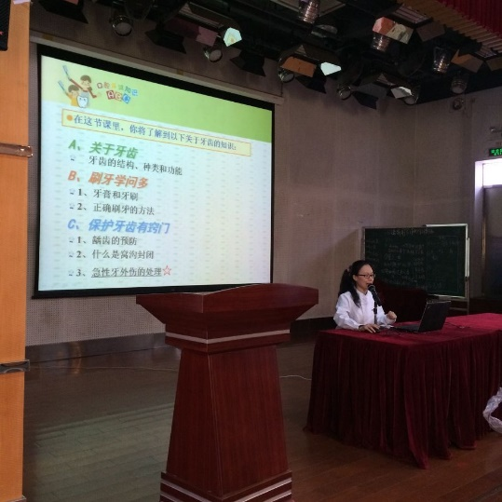

Supplementary Fig. 1. Parent’s lecture at Primary School Affiliated to Guangdong University of Foreign Studies.

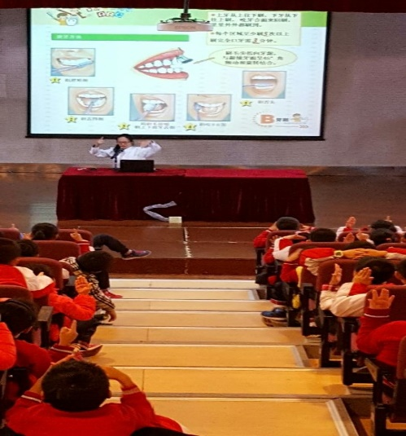

Supplementary Fig. 2. Children’s lecture at Primary School Affiliated to Guangdong University of Foreign Studies.

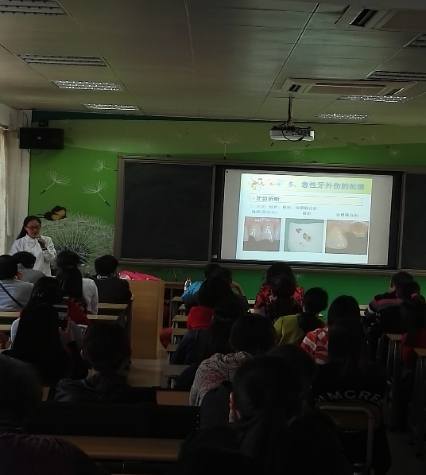

Supplementary Fig. 3. Parent’s lecture at Xiancun Primary School.

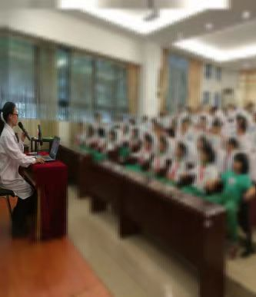

Supplementary Fig. 4. Children’s lecture at Xiancun Primary School.



**Supplementary Fig. 5. Parent’s lecture at Tiyudong Primary School.**

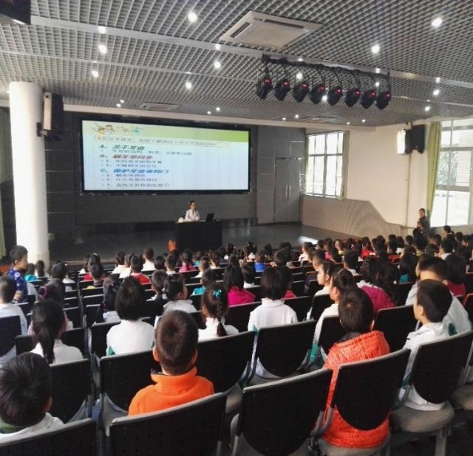

**Supplementary Fig. 6. Children’ s lecture at Tiyudong Primary School.**

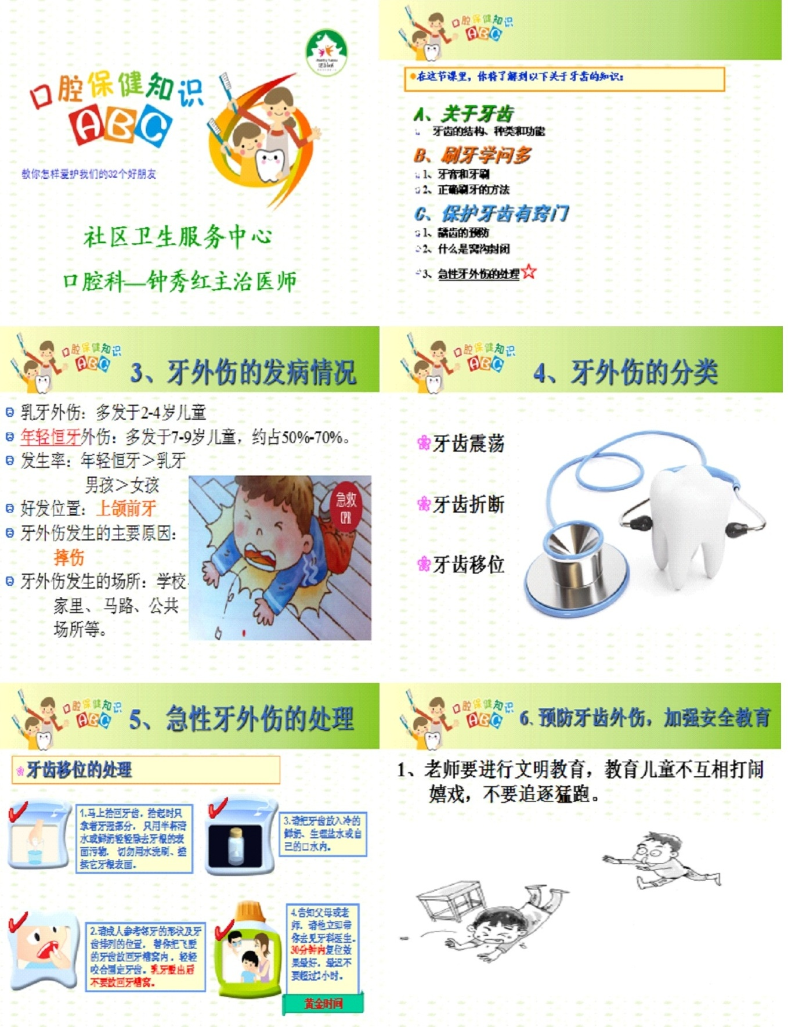

Supplementary Fig. 7. Part of the PPT Information. PPT: PowerPoint.